2019
Deborah Guy
Crossing Bridges Coaching, LLC

Coaching Services for the Personal Work of A Professional Life.
Hi!
I’m glad that our brief time together was of value to you. I look forward to being of service to you on your journey forward. As promised, I am sharing the following information regarding my phased approach and recommendation for your consideration.
You know your strengths as a professional in your area of expertise. I know my strengths as an expert in the field of co-active coaching, fear mastery, career pivot and development, and, when needed, job search expertise. If we start there, we can join these strengths together to create the increased clarity, confidence, and satisfaction that aligns with your vision for this decade of your journey.
Throughout your time with me, I will support you in gaining clarity around the next best steps for you and I will be a witness to what you say you want. Remember our core agreement with each other.
- No holding back
- I’ll be asking both ‘low flame’ questions and ‘higher flame’ questions, and you agree to be open to both.
- Remember that my purpose is to be of service to you, not to please you and not to tell you what you want to hear.
Along the way you’ll learn skills, tools and mindset shifts you need to know to identify and overcome self-defeating behavior and tackle your goal progression with confidence. These are skills, once fully integrated, will serve you well for the rest of your life, above and beyond your personal and career goals.
Note that while you will learn a lot, we both know that Ah-ha moments, as powerful as they are, don’t change your life; only action does that. In each session, we determine together the best action items for you to tackle for your best forward movement. We’ll address the obstacles that might derail you so you can pre-cover for eventualities instead of having to re-cover from a missed opportunity. All related material, templates, assessments, and paradigm-shifting exercises are included except as noted.
Looking forward and Fearless Best Regards,
Deborah
P.S. If you feel you’ve shared a bit more than you were initially planning to, or if our discussion struck a chord (or a nerve) with you that continued to weave itself into your day, know that our body often responds to such things and that ‘vulnerability hangovers’ are very real. You might feel a bit off for the next 24 hours or so. That’s normal. Be gentle with yourself, and practice extreme self-care for the next couple of days. With care, D.

Our Focus:

Your Vision: Intentionally create clarity in designing and executing on a plan for showcasing your vision and value. Strive to create a balanced and fulfilling future. To use working with a coach with expertise in fear mastery as a catalyst, and powerful partner in bringing this vision to fruition through ongoing alignment of action items with vision, clarity of purpose, fear mastery, and best practices in personal effectiveness.
Strategy – You’ll use our next session, your strategy session, to continue to create clarity, framework, and action items that move your goal forward and a plan for keeping you on course and focused. Future sessions will be dedicated to enacting your strategy, and making adjustments as needed.
Mindset – Along the way, we’ll identify blind-spots in thinking or approaches that aren’t supporting your goals and work to align your actions with your vision for your life and career.
Skillset – Develop a fear mastery framework, habits of effectiveness, and tools for your objectives.
Energy – We’ll identify the thoughts, interactions, and behaviors that zap your energy as well as the relationships and activities that energize you. We’ll specifically work to reduce the energy zappers and rebalance these in your week with the things that energize you with consistency. We focus on this precisely so that you have the best kind of energy to take making your vision a reality.
You are not broken, you don’t need fixing. There are simply some skills you need to be willing to learn, and then practice, to create increased clarify, confidence, and forward movement in one or more areas of your life. As discussed, we would establish a framework based on building a Fearless Foundation to support you in getting and staying out of your way as we tackle your career goals in an organized and concrete way.
The only wrong way to engage with our work together is to engage half-heartedly.
First things first, I Invite you to take the next day or so to consider all the reasons not to work with me.
Then, consider all the reasons that engaging in this specific client-coach relationship at this time would benefit you. Think about how you can use our partnership to create the focus and forward momentum to creating the life and career your soul intended.
I invite you to choose to work with me to begin a new chapter in your personal and professional career in a highly effective way.
Engaging in any coach-client relationship will take effort, but I promise you that our work together will create much more success, far more quickly and more efficiently than going it alone.

A Phased Approach

I approach each client as a whole person. I know their personal life impacts their professional life and vice versa.
The phase-by-phase structured approach I’ve developed over the years supports an excellent foundation for your success and is best for individuals who are interested in intentionally designing or redesigning the next phase in their life or career.
What follows is an overview of each phase, followed by a recommendation for you based on our exploratory discussion.
Regardless of where you begin, I’ll always stand at the ready to help you stay out of your own way and on a course toward your wildly important goals with confidence.
Engaging in one phase in no way obligates you to take on another. I’ve simply put my program together in a way that, through working with clients, I’ve determined works best. I’ve also designed each phase to be completely independent of the other and yet work together beautifully.

Phase 1: Fearless Foundations
Phase 2: Fearless Follow-Through (Select 1)
- Career Pivot and Job Search
- Passion Project
Phase 3: Maintain Momentum (Highly Recommended, completely optional)
Strategic Intervention

Overview of Each Phase.

Phase 1: Fearless Foundations (Coaching Retainer: 6 Months)
  - Raise awareness around the mindsets, limiting beliefs and blind spots that may be keeping you from accomplishing your most important goals.
  - Identify self-sabotaging behavior and practice replacing it with new tools and skills that are more useful to your goals both personally and professionally consistently.
  - Take concrete steps using proven approaches for achieving their wildly important goals. This may, or may not, include a career pivot or job search.
  - Learn to effectively navigate toward the fear busters in your life and mitigate the influence of ‘fear junkies’
This much-loved phase contains a clear, proven, coached approach to setting yourself up for success through personal effectiveness strategies that impact all areas of your life. Mastering your personal saboteurs, strengthening fear-busting relationships, and eliminate the impact of fear-junkie relationships and set healthier boundaries around people and activities that no longer serve you. Get out of your own way and on with your best life.

Phase 2: Fearless Follow Through

Option 1: Recruiting Your Next Employer: Career Pivot and Job Search (Coaching Retainer: 4 Months)
- Clarity: Best Direction and Most Viable Target Markets
- Campaign: Effective Targeting, Pitch, Resume, LinkedIn Profile, Online Presence
- Canvas: Effective Networking, Search Firms, Job Boards, Hidden Job Market
- Connect: Acing Your Interview
- Carry Through: Building and Maintaining A Robust Approach that builds momentum. Negotiating an Offer, and setting yourself up for your best success for the first three months on the job.

Option 2: Passion Project: Entrepreneurs and Artists (Coaching Retainer: 4 -12 Months depending on scale of Project)

Part 1: Lay the Groundwork
- Clarity: The Right Project for the Right Reasons
- Alignment: Ambition and Life Style Decisions
- Connection: Who You Serve/Who is Your Audience
- Sustainability: Resources (including, knowing your strengths & supplementing non-strength areas, Funding)
- Integrating Factors For Your Best Success

Part 2: Down to Business

- Profit Planning
- Customer/Audience Avatar
- Premium Brand Position
- Leveraging What Makes You Unique
- Making Competition Irrelevant
- Website/Portfolio Creation
- Content and Communication
- List Building
- Offer Clarity
- Marketing

Phase 3: Maintain Momentum (Not avail. for New Clients. Provided for Your Reference., Subscription-based)
We’ve worked through phase 1 and phase 2, established momentum, and are using this phase to reinforce useful habits and navigate new situations as they arise in a way that supports you in operating from a place of freedom and best practices and not old fear-based habits. Continues to reinforce fear mastery approaches from phase 1 and best practices from phase 2.
Two Sessions per Month: You may be hitting your stride and want ongoing coached support to tackle any future obstacles or needed adjustments to your plan. Most importantly to make sure you stay on course and are not slipping into behavior that could sabotage even your best efforts. Engage in the personalized coaching you need to stay out of your own way and continue your robust plan of action. Highly recommended and completely optional.
Single Session per Month: You’ve become well versed and are confident in your skillset and tools. A monthly tune-up will keep you sharp, on task and moving forward successfully. Avoid the pitfall of falling back into old habits. Highly recommended and completely optional.
Momentum Phase is a Subscription format. It will likely include assignments for completion outside of scheduled sessions. Discontinue at any time.

Strategic Intervention Retainer

Strategic Intervention (Coaching Retainer: 3 – 6 Months depending on scope)
Use this stand-alone Strategic Intervention Retainer to tackle a specific spot in your career or life that you’ve been tackling on your own but feeling stuck or stagnant in your progress. We’ll only address what you specifically need to insure ongoing forward movement toward your chosen goals. While not a substitute for either Phase 1 or Phase Phase 2 , we’ll draw on elements from both as needed.
Excellent for the professional who has already made a valiant effort at a successful career pivot, job search, passion project or personal relationship or goal and are finding it difficult to gain traction, not sure where the problem lies or realizes they may be getting in their way in having a successful outcome.

My Recommendation
Based on our discussion, I believe that the Strategic Intervention Retainer would best meet your needs.
Standard 3-month Minimum Retainer $1,550 ($500 non-refundable deposit/setup fee and monthly retainer payments of $350 for three consecutive months). Consists of One 90-minute strategy session. Five 45-50 minute, bi-weekly coaching sessions. Ongoing correspondence related to action items, questions, comments, and feedback between sessions, as needed. Retainer Includes all material, recommended assessments, online systems, and job search tools unless otherwise noted. The retainer period begins with the date of your Strategy Session and continues for 90 days. After 90 days your retainer will roll over into the Maintaining Momentum phase and continue until you choose to move to a one session only per month or suspend coaching.

Your Timeline, My Roster

To give each of my clients and myself the bandwidth that supports them effectively, I only work with a finite number of clients at a time. If you are receiving this, it is because, at this moment, there is a spot in my roster for you, which I will hold for you for three days, as agreed. After that, the spot is released. However, there is no rush on my part. Your timeline is your own.
If you are ready to move forward, make your $500 deposit and claim a start date by scheduling your initial session. Your deposit holds a spot for you in my roster rotation starting on your chosen date. It guarantees you the rate quoted in this proposal, and 100% of your deposit goes toward your retainer balance. Your first retainer payment of $350.00 will be processed three business days before your initial Strategy Session. The schedule of fees will be available within GuyBridge for your review, and you will receive an invoice and receipt for each.
If you are not moving forward at this time, that’s fine too. Let me know as soon as you’ve made that decision. The spot will be released, and you may re-engage to explore a coaching opportunity with me again after six months.

What You Need to Know in General:

GuyBridge.Net – This is your personal dashboard for your progress. As we progress, it is tailored to meet your needs and will include access to the tools needed for your specific goals. It is included in your retainer at no additional cost to you. An Invitation to access your dashboard will be sent once your deposit is received.
Unless otherwise noted, I invite you to keep all the work we do and any correspondence going forward confidentially within GuyBridge.Net.
Scheduling. My calendar is staked out pretty much three months in advance at all times, I’ll be inviting you to use the online calendar in GuyBridge.Net to set your appointments throughout the retainer during our initial strategy session. Schedule each approximately two weeks apart, unless we’ve agreed to an alternate schedule. As needed, we can reschedule or move a session forward or back as we go along, but please secure your dates as soon as possible. Otherwise, at some point, especially if you are a procrastinator when it comes to the tough stuff, you may find yourself just fading away from your goal, and you’re hiring me to support you in that not happening. So, schedule your sessions into the future.
Between sessions, there will be action items to complete that align with your goals, and I am available to you between sessions via your dashboard. If you get stuck, drop me a line.
Preparation and Agenda A Client/Coach Partnership is very dynamic. I’ll ask you to complete a brief Session Prep Form at least 24 hours before each session. You won’t have to tell me what you’ve completed, as I’ll be able to see that from your action list. Use this space instead to share where you are struggling, delaying progress, or, equally important, where you are celebrating and acknowledging yourself. The agenda for each session is built upon the contents of the prep form and progress made between sessions. I prefer to prepare in advance and can only do that if I have your input via your prep form. Regardless of what you may have heard, I am not a mind-reader.
Rescheduling can be done 100% via the GuyBridge System up to 24 hours before a session starts without loss of session time. You will not be able to reschedule a session within 24 hours of the appointment. Missed, or ‘ghosted’ sessions are forfeited sessions. If you are late to a session, the session cannot be extended. Extenuating circumstances are, of course, taken into consideration, please write to me directly using the message feature in GuyBridge.Net.
Happenings Report (Optional) If you need your progress to be shared with a third-party, e.g., employer, mentor, benefactor, etc. please let me know in writing along with email contact information within the first seven days of the retainer. Reports sent monthly.
Well, that’s everything from me!
Take your time, look through everything thoroughly, ask your questions, and make your decision below.

Looking Forward and Fearless Best Regards,
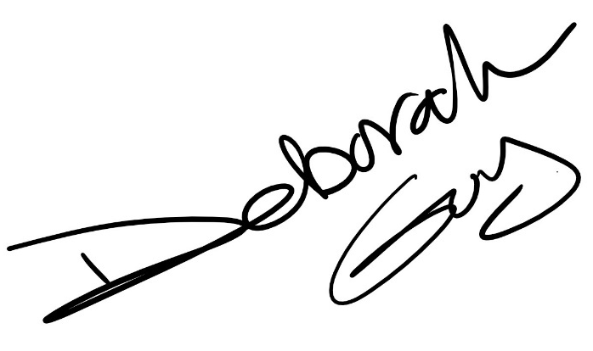

Next Steps

- Review everything and ask any questions you have via email at sayhi@DeborahGuy.Com
- If you haven’t already, think of all the reasons you shouldn’t work with me.
- Then, consider all the reasons that engaging in this specific client-coach relationship at this time would benefit you. Think about how you can use our partnership to create the focus and forward momentum to achieve your career goal. I invite you to choose to work with me to raise the level of your personal effectiveness in your personal and professional career. Engaging in any coach-client relationship will take effort, but I promise you that our work together will create much more success, far more quickly and more efficiently than going it alone.
- Use the link below to complete deposit payment and select your initial Strategy session date by, Saturday, January 30th, 2021. The Strategy session does not have to take place by then. You simply need to schedule it when you make your deposit.

Click HERE to secure your spot on Deborah’s roster, schedule your 90 minute private strategy session and make your deposit.

If for any reason the link does not work, copy and paste the following link into your browser to continue:
https://www.coachaccountable.com/offering/PcbkJcIxLpPUGkCht7RrbuuF7IIuQMs

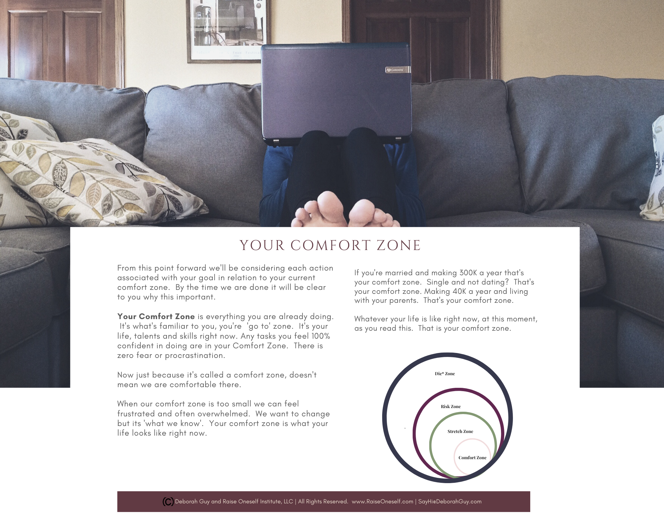

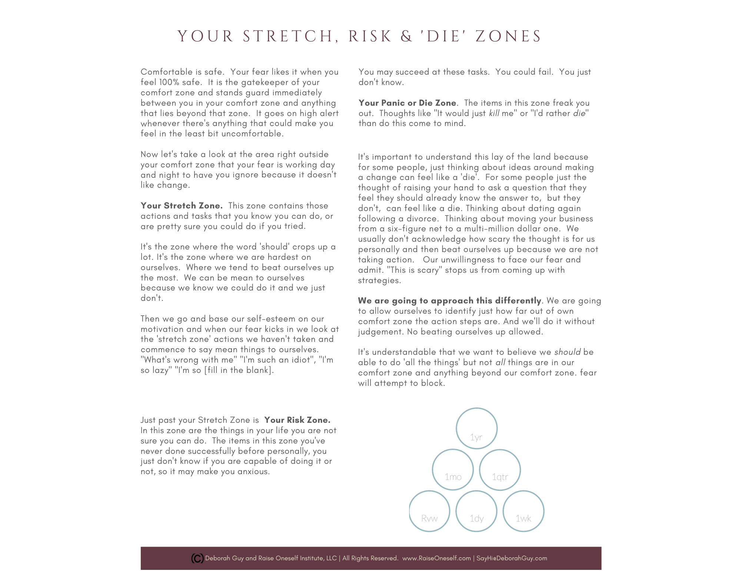

Your Turn

- Review everything and ask any questions you have via GuyBridge.Net or email at sayhi@DeborahGuy.Com.
- If you haven’t already, think of all the reasons you shouldn’t work with me.
- Then, consider all the reasons that engaging in this specific client-coach relationship at this time would benefit you. Think about how you can use our partnership to create the focus and forward momentum to achieve your career goal. I invite you to choose to work with me to raise the level of your personal effectiveness in your personal and professional career. Engaging in any coach-client relationship will take effort, but I promise you that our work together will create much more success, far more quickly and more efficiently than going it alone.
- Use the link below to complete deposit payment and select your initial Strategy session date by, Saturday, January 30th, 2021. The Strategy session does not have to take place by then. You simply need to schedule it when you make your deposit.

Click HERE to secure your spot on Deborah’s roster, schedule your 90 minute private strategy session and make your deposit.

If for any reason the link does not work, copy and paste the following link in to your browser to continue:
https://www.coachaccountable.com/offering/PcbkJcIxLpPUGkCht7RrbuuF7IIuQMs

For Your Reference
Our Focus: 4
A Phased Approach 6
Overview of Each Phase. 7
Phase 1: Fearless Foundations (Coaching Retainer: 6 Months) 7
Phase 2: Fearless Follow Through 8
Option 1: Recruiting Your Next Employer: Career Pivot and Job Search (Coaching Retainer: 4 Months) 8
Option 2: Passion Project: Entrepreneurs and Artists (Coaching Retainer: 4 -12 Months depending on scale of Project) 8
Phase 3: Maintain Momentum (Not avail. for New Clients. Provided for Your Reference., Subscription-based) 9
Strategic Intervention Retainer 10
Strategic Intervention (Coaching Retainer: 3 – 6 Months depending on scope) 10
My Recommendation 11
Your Timeline, My Roster 12
What You Need to Know in General: 13
GuyBridge.Net 13
Scheduling. 13
Preparation and Agenda 13
Rescheduling 14
Happenings Report (Optional) 14
Next Steps 15
Your Turn 18

Click HERE to secure your spot on Deborah’s roster.

If for any reason the link does not work, copy and paste the following link in to your browser to continue:
https://www.coachaccountable.com/offering/PcbkJcIxLpPUGkCht7RrbuuF7IIuQMs

